ultramirinc.champs_mood

Class CreditsActivity

java.lang.Object

android.content.Context

android.content.ContextWrapper

android.view.ContextThemeWrapper

android.app.Activity

android.support.v4.app.SupportActivity

android.support.v4.app.FragmentActivity

android.support.v7.app.AppCompatActivity ultramirinc.champs_mood.CreditsActivity

All Implemented Interfaces:

android.content.ComponentCallbacks, android.content.ComponentCallbacks2, android.support.v4.app.ActivityCompat.OnRequestPermissionsResultCallback, android.support.v4.app.ActivityCompatApi23.RequestPermissionsRequestCodeValidator, android.support.v4.app.TaskStackBuilder.SupportParentable, android.support.v7.app.ActionBarDrawerToggle.DelegateProvider, android.support.v7.app.AppCompatCallback, android.view.KeyEvent.Callback, android.view.LayoutInflater.Factory, android.view.LayoutInflater.Factory2, android.view.View.OnCreateContextMenuListener, android.view.Window.Callback



public class CreditsActivity

extends android.support.v7.app.AppCompatActivity

Created by William on 2017­05­04. This activity shows the credits given to each person who directly or indirectly helped us achieve this project



*Nested Class Summary*

Nested classes/interfaces inherited from class android.support.v4.app.SupportActivity

android.support.v4.app.SupportActivity.ExtraData

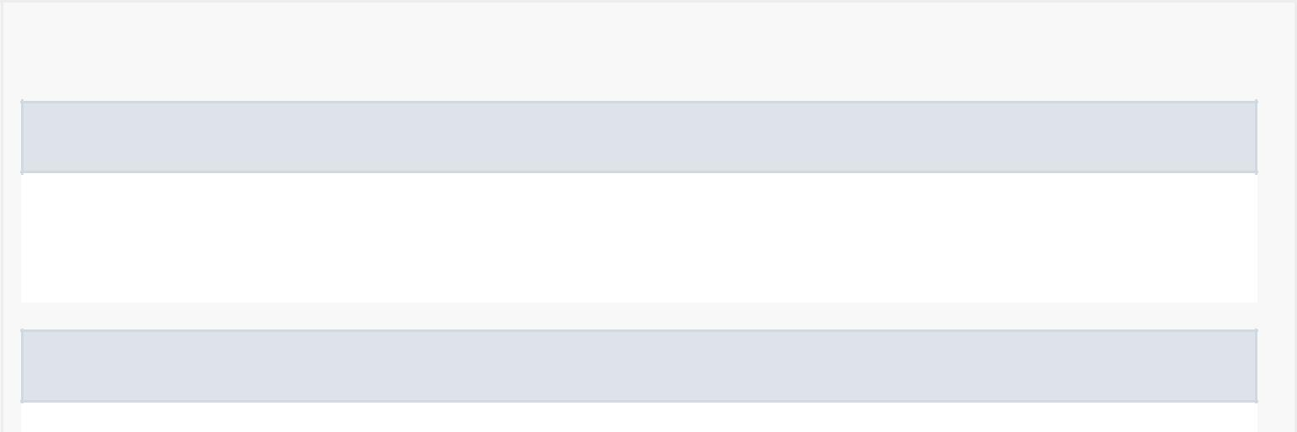

*Field Summary*

Fields inherited from class android.app.Activity

DEFAULT_KEYS_DIALER, DEFAULT_KEYS_DISABLE, DEFAULT_KEYS_SEARCH_GLOBAL,

DEFAULT_KEYS_SEARCH_LOCAL, DEFAULT_KEYS_SHORTCUT, FOCUSED_STATE_SET,

RESULT_CANCELED, RESULT_FIRST_USER, RESULT_OK

Fields inherited from class android.content.Context

ACCESSIBILITY_SERVICE, ACCOUNT_SERVICE, ACTIVITY_SERVICE, ALARM_SERVICE,



APP_OPS_SERVICE, APPWIDGET_SERVICE, AUDIO_SERVICE, BATTERY_SERVICE,

BIND_ABOVE_CLIENT, BIND_ADJUST_WITH_ACTIVITY, BIND_ALLOW_OOM_MANAGEMENT,

BIND_AUTO_CREATE, BIND_DEBUG_UNBIND, BIND_EXTERNAL_SERVICE, BIND_IMPORTANT,

BIND_NOT_FOREGROUND, BIND_WAIVE_PRIORITY, BLUETOOTH_SERVICE, CAMERA_SERVICE,

CAPTIONING_SERVICE, CARRIER_CONFIG_SERVICE, CLIPBOARD_SERVICE,

CONNECTIVITY_SERVICE, CONSUMER_IR_SERVICE, CONTEXT_IGNORE_SECURITY,

CONTEXT_INCLUDE_CODE, CONTEXT_RESTRICTED, DEVICE_POLICY_SERVICE, DISPLAY_SERVICE,

DOWNLOAD_SERVICE, DROPBOX_SERVICE, FINGERPRINT_SERVICE,

HARDWARE_PROPERTIES_SERVICE, INPUT_METHOD_SERVICE, INPUT_SERVICE,

JOB_SCHEDULER_SERVICE, KEYGUARD_SERVICE, LAUNCHER_APPS_SERVICE,

LAYOUT_INFLATER_SERVICE, LOCATION_SERVICE, MEDIA_PROJECTION_SERVICE,

MEDIA_ROUTER_SERVICE, MEDIA_SESSION_SERVICE, MIDI_SERVICE, MODE_APPEND,

MODE_ENABLE_WRITE_AHEAD_LOGGING, MODE_MULTI_PROCESS, MODE_NO_LOCALIZED_COLLATORS,

MODE_PRIVATE, MODE_WORLD_READABLE, MODE_WORLD_WRITEABLE, NETWORK_STATS_SERVICE,

NFC_SERVICE, NOTIFICATION_SERVICE, NSD_SERVICE, POWER_SERVICE, PRINT_SERVICE,

RESTRICTIONS_SERVICE, SEARCH_SERVICE, SENSOR_SERVICE, SHORTCUT_SERVICE,

STORAGE_SERVICE, SYSTEM_HEALTH_SERVICE, TELECOM_SERVICE, TELEPHONY_SERVICE,

TELEPHONY_SUBSCRIPTION_SERVICE, TEXT_SERVICES_MANAGER_SERVICE, TV_INPUT_SERVICE,

UI_MODE_SERVICE, USAGE_STATS_SERVICE, USB_SERVICE, USER_SERVICE, VIBRATOR_SERVICE,

WALLPAPER_SERVICE, WIFI_P2P_SERVICE, WIFI_SERVICE, WINDOW_SERVICE

Fields inherited from interface android.content.ComponentCallbacks2

TRIM_MEMORY_BACKGROUND, TRIM_MEMORY_COMPLETE, TRIM_MEMORY_MODERATE,

TRIM_MEMORY_RUNNING_CRITICAL, TRIM_MEMORY_RUNNING_LOW,

TRIM_MEMORY_RUNNING_MODERATE, TRIM_MEMORY_UI_HIDDEN

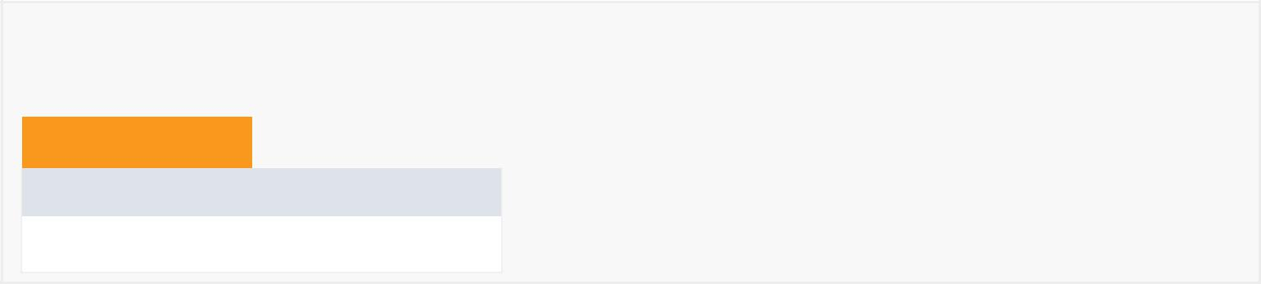

*Constructor Summary*

Constructors

Constructor and Description

CreditsActivity()

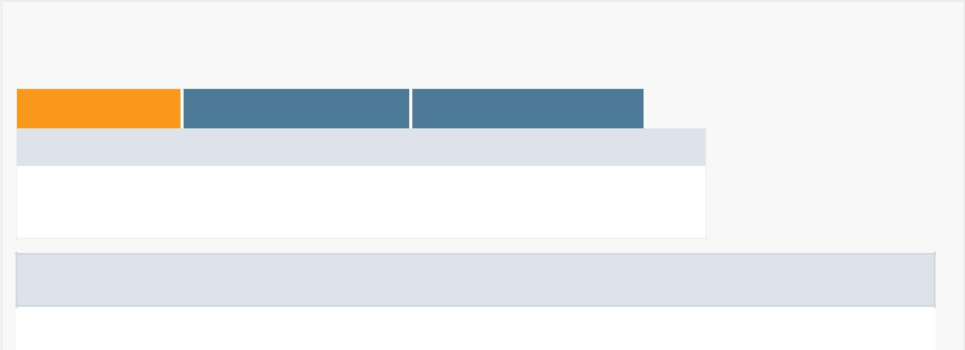

*Method Summary*

All Methods [Instance Methods](javascript:show(2);) [Concrete Methods](javascript:show(8);)

Modifier and Type Method and Description

protected void onCreate(android.os.Bundle savedInstanceState)

Creates and inflates the layout for the activity

Methods inherited from class android.support.v7.app.AppCompatActivity

addContentView, dispatchKeyEvent, findViewById, getDelegate, getDrawerToggleDelegate, getMenuInflater, getResources, getSupportActionBar, getSupportParentActivityIntent, invalidateOptionsMenu, onConfigurationChanged, onContentChanged, onCreateSupportNavigateUpTaskStack, onDestroy, onMenuItemSelected, onMenuOpened, onPanelClosed, onPostCreate, onPostResume, onPrepareSupportNavigateUpTaskStack, onSaveInstanceState, onStart, onStop, onSupportActionModeFinished, onSupportActionModeStarted, onSupportContentChanged, onSupportNavigateUp, onTitleChanged, onWindowStartingSupportActionMode, setContentView, setContentView, setContentView, setSupportActionBar, setSupportProgress, setSupportProgressBarIndeterminate, setSupportProgressBarIndeterminateVisibility, setSupportProgressBarVisibility, setTheme, startSupportActionMode, supportInvalidateOptionsMenu, supportNavigateUpTo, supportRequestWindowFeature, supportShouldUpRecreateTask



Methods inherited from class android.support.v4.app.FragmentActivity

dump, getLastCustomNonConfigurationInstance, getSupportFragmentManager, getSupportLoaderManager, getSupportMediaController, onActivityResult, onAttachFragment, onBackPressed, onCreatePanelMenu, onLowMemory, onMultiWindowModeChanged, onNewIntent, onPause, onPictureInPictureModeChanged, onPrepareOptionsPanel, onPreparePanel, onRequestPermissionsResult, onResume, onResumeFragments, onRetainCustomNonConfigurationInstance, onRetainNonConfigurationInstance, onStateNotSaved, setEnterSharedElementCallback, setExitSharedElementCallback, setSupportMediaController, startActivityForResult, startActivityFromFragment, startActivityFromFragment, startIntentSenderFromFragment, supportFinishAfterTransition, supportPostponeEnterTransition, supportStartPostponedEnterTransition, validateRequestPermissionsRequestCode

Methods inherited from class android.support.v4.app.SupportActivity

getExtraData, putExtraData

Methods inherited from class android.app.Activity

closeContextMenu, closeOptionsMenu, createPendingResult, dismissDialog, dismissKeyboardShortcutsHelper, dispatchGenericMotionEvent, dispatchKeyShortcutEvent, dispatchPopulateAccessibilityEvent, dispatchTouchEvent, dispatchTrackballEvent, enterPictureInPictureMode, finish, finishActivity, finishActivityFromChild, finishAffinity, finishAfterTransition, finishAndRemoveTask, finishFromChild, getActionBar, getApplication, getCallingActivity, getCallingPackage, getChangingConfigurations, getComponentName, getContentScene, getContentTransitionManager, getCurrentFocus, getFragmentManager, getIntent, getLastNonConfigurationInstance, getLayoutInflater, getLoaderManager, getLocalClassName, getMediaController, getParent, getParentActivityIntent, getPreferences, getReferrer, getRequestedOrientation, getSearchEvent, getSystemService, getTaskId, getTitle, getTitleColor, getVoiceInteractor, getVolumeControlStream, getWindow, getWindowManager, hasWindowFocus, isChangingConfigurations, isChild, isDestroyed, isFinishing, isImmersive, isInMultiWindowMode, isInPictureInPictureMode, isLocalVoiceInteractionSupported,

isTaskRoot, isVoiceInteraction, isVoiceInteractionRoot, managedQuery, moveTaskToBack, navigateUpTo, navigateUpToFromChild, onActionModeFinished, onActionModeStarted, onActivityReenter, onApplyThemeResource, onAttachedToWindow, onAttachFragment, onChildTitleChanged, onContextItemSelected, onContextMenuClosed, onCreate, onCreateContextMenu, onCreateDescription, onCreateDialog, onCreateDialog, onCreateNavigateUpTaskStack, onCreateOptionsMenu, onCreatePanelView, onCreateThumbnail, onDetachedFromWindow, onEnterAnimationComplete, onGenericMotionEvent, onKeyDown, onKeyLongPress, onKeyMultiple, onKeyShortcut, onKeyUp, onLocalVoiceInteractionStarted, onLocalVoiceInteractionStopped, onNavigateUp, onNavigateUpFromChild, onOptionsItemSelected, onOptionsMenuClosed, onPostCreate, onPrepareDialog, onPrepareDialog, onPrepareNavigateUpTaskStack, onPrepareOptionsMenu, onProvideAssistContent, onProvideAssistData, onProvideKeyboardShortcuts, onProvideReferrer, onRestart, onRestoreInstanceState, onRestoreInstanceState, onSaveInstanceState, onSearchRequested, onSearchRequested, onTouchEvent, onTrackballEvent, onTrimMemory, onUserInteraction, onUserLeaveHint, onVisibleBehindCanceled, onWindowAttributesChanged, onWindowFocusChanged, onWindowStartingActionMode, onWindowStartingActionMode, openContextMenu, openOptionsMenu, overridePendingTransition, postponeEnterTransition, recreate, registerForContextMenu, releaseInstance, removeDialog, reportFullyDrawn, requestDragAndDropPermissions, requestPermissions, requestShowKeyboardShortcuts, requestVisibleBehind, requestWindowFeature, runOnUiThread, setActionBar, setContentTransitionManager, setDefaultKeyMode, setEnterSharedElementCallback, setExitSharedElementCallback, setFeatureDrawable, setFeatureDrawableAlpha, setFeatureDrawableResource, setFeatureDrawableUri, setFinishOnTouchOutside, setImmersive, setIntent, setMediaController, setProgress, setProgressBarIndeterminate, setProgressBarIndeterminateVisibility, setProgressBarVisibility, setRequestedOrientation, setResult, setResult, setSecondaryProgress, setTaskDescription, setTitle, setTitle, setTitleColor, setVisible, setVolumeControlStream, setVrModeEnabled, shouldShowRequestPermissionRationale, shouldUpRecreateTask, showAssist, showDialog, showDialog, showLockTaskEscapeMessage, startActionMode, startActionMode, startActivities, startActivities, startActivity, startActivity, startActivityFromChild, startActivityFromChild, startActivityFromFragment, startActivityFromFragment, startActivityIfNeeded, startActivityIfNeeded, startIntentSender, startIntentSender, startIntentSenderFromChild, startIntentSenderFromChild, startLocalVoiceInteraction, startLockTask, startManagingCursor, startNextMatchingActivity, startNextMatchingActivity, startPostponedEnterTransition, startSearch, stopLocalVoiceInteraction, stopLockTask, stopManagingCursor, takeKeyEvents, triggerSearch, unregisterForContextMenu



Methods inherited from class android.view.ContextThemeWrapper

applyOverrideConfiguration, attachBaseContext, getAssets, getTheme

Methods inherited from class android.content.ContextWrapper

bindService, checkCallingOrSelfPermission, checkCallingOrSelfUriPermission, checkCallingPermission, checkCallingUriPermission, checkPermission, checkSelfPermission, checkUriPermission, checkUriPermission, clearWallpaper,

createConfigurationContext, createDeviceProtectedStorageContext, createDisplayContext, createPackageContext, databaseList, deleteDatabase, deleteFile, deleteSharedPreferences, enforceCallingOrSelfPermission, enforceCallingOrSelfUriPermission, enforceCallingPermission, enforceCallingUriPermission, enforcePermission, enforceUriPermission, enforceUriPermission, fileList, getApplicationContext, getApplicationInfo, getBaseContext, getCacheDir, getClassLoader, getCodeCacheDir, getContentResolver, getDatabasePath, getDataDir, getDir, getExternalCacheDir, getExternalCacheDirs, getExternalFilesDir, getExternalFilesDirs, getExternalMediaDirs, getFilesDir, getFileStreamPath, getMainLooper, getNoBackupFilesDir, getObbDir, getObbDirs, getPackageCodePath, getPackageManager, getPackageName, getPackageResourcePath, getSharedPreferences, getSystemServiceName, getWallpaper, getWallpaperDesiredMinimumHeight, getWallpaperDesiredMinimumWidth, grantUriPermission, isDeviceProtectedStorage, isRestricted, moveDatabaseFrom, moveSharedPreferencesFrom, openFileInput, openFileOutput, openOrCreateDatabase, openOrCreateDatabase, peekWallpaper, registerReceiver, registerReceiver, removeStickyBroadcast, removeStickyBroadcastAsUser, revokeUriPermission, sendBroadcast, sendBroadcast, sendBroadcastAsUser, sendBroadcastAsUser, sendOrderedBroadcast, sendOrderedBroadcast, sendOrderedBroadcastAsUser, sendStickyBroadcast, sendStickyBroadcastAsUser, sendStickyOrderedBroadcast, sendStickyOrderedBroadcastAsUser, setWallpaper, setWallpaper, startInstrumentation, startService, stopService, unbindService, unregisterReceiver



Methods inherited from class android.content.Context

getColor, getColorStateList, getDrawable, getString, getString, getSystemService, getText, obtainStyledAttributes, obtainStyledAttributes, obtainStyledAttributes, obtainStyledAttributes, registerComponentCallbacks, unregisterComponentCallbacks

Methods inherited from class java.lang.Object

clone, equals, finalize, getClass, hashCode, notify, notifyAll, toString, wait, wait, wait

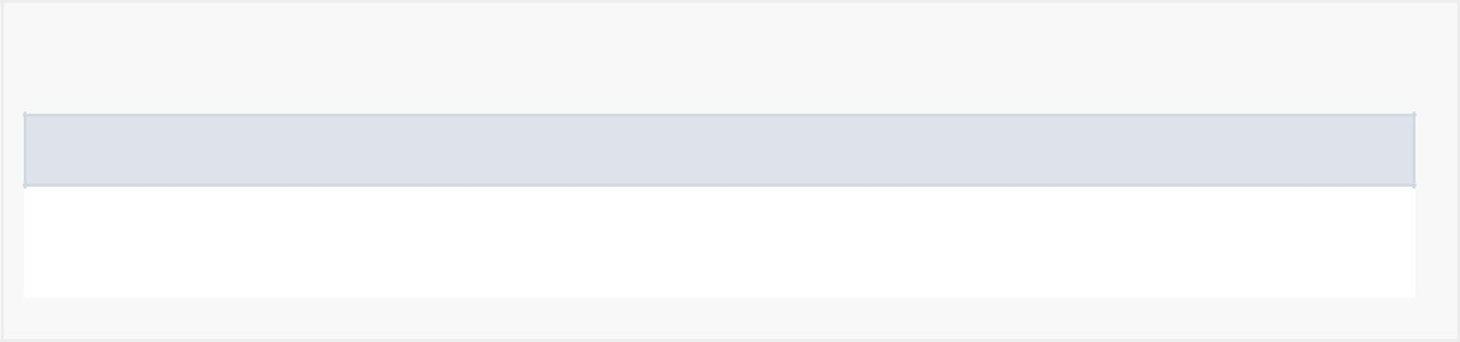

*Constructor Detail*

CreditsActivity

public CreditsActivity()

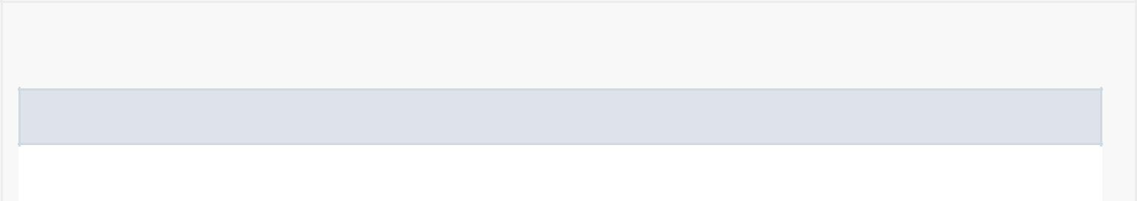

*Method Detail*

onCreate

protected void onCreate(android.os.Bundle savedInstanceState)

Creates and inflates the layout for the activity

Overrides:

onCreate in class android.support.v7.app.AppCompatActivity